Documentation for Laba#4

Zakharchenko Anna

In this document I will describe the functionality of my code and what each function does. At first, I will show the input and output of functions in my code.

At first, it shows Menu in which we can see 6 options. I use a while loop for creating a menu.

The loop continues until the user chooses to exit (option 6). Depending on the users choice , it calls the function to persorm the desired operation on the linked list.

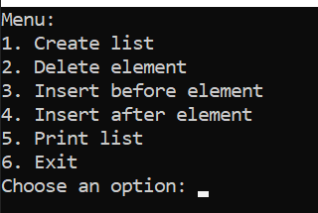

1) CreateList() – This function creates a linked list of nodes be taking user input for cout and inserting them in sorted order using InserSorted()(this function returns a pointer to the head of the list).

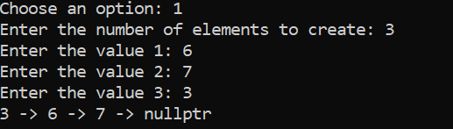

2) DeleteNode() - this function removes a node with the given data value from the linked list.

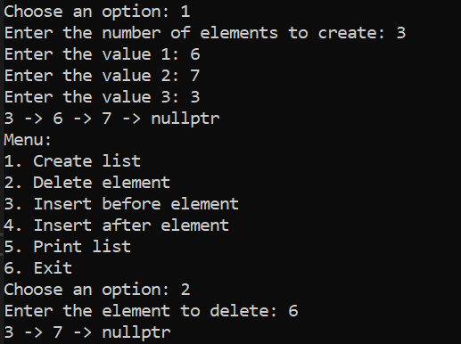

3) insertBefore() – This function inserts a new node with the given data before a node with the target value in the linked list.

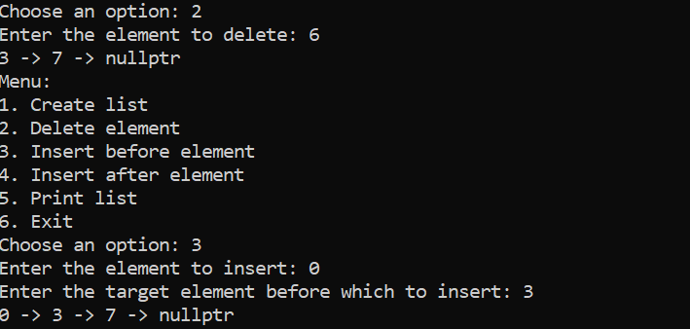

4) insertAfter() - This function inserts a new node with the given data after a node with the target value in the linked list.

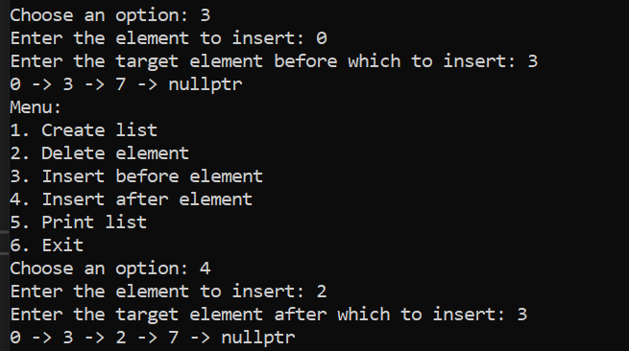

5) PrintList() - This function prints the elements of the linked list, starting from the node pointed to by current.